Clients are asked to bring their own electronic devices to fill out the electronic “CRC Sampling Request Form.”
- If I am at the Core Research Centre (CRC), will an electronic device be provided?
- You are encouraged to bring your own electronic devices to fill out the form. An iPad will be provided if necessary.
- Will there be Wi-Fi at the CRC so that I can connect my own device?
- Yes. CRC front desk staff will provide you with the Wi-Fi credentials.
- What agreement am I making when I submit the sampling form?
- By submitting the form, you agree to sample and test core only at the depths approved by AER staff and perform only the approved tests types. If changes are needed, you may request approval to modify the test types or re-sample different depths. You also agree to submit all relevant core, samples, drill cuttings, thin sections, and test results by the deadlines set by AER staff. Submission deadlines may be adjusted based on testing wait times and requirements.
- Where can I find whether a well has core or drill cuttings available for sampling?
- The Core and Drill Cutting Map Viewer.
- Can I save a partially completed sampling form and return to submit at a later time?
- No, you cannot save the form as a draft to submit in a subsequent session. However, if you leave the browser tab open, the information already entered should remain on the form.
- On the Add Material & Interval screen, what unit of measure should I use for the interval?
- Select the interval units that matches the measurement system you used to measure the core or drill cuttings.
- What size plugs can be cut at the CRC?
- The CRC can cut 1- and 1½-inch plugs. Larger plugs must be cut at an off-site lab.
- If I am doing multiple test types on a sample depth, where do I add the additional test types?
- In the “Analysis that will be performed” section of the Add Material & Interval screen, select the drop-down box and choose all relevant tests.
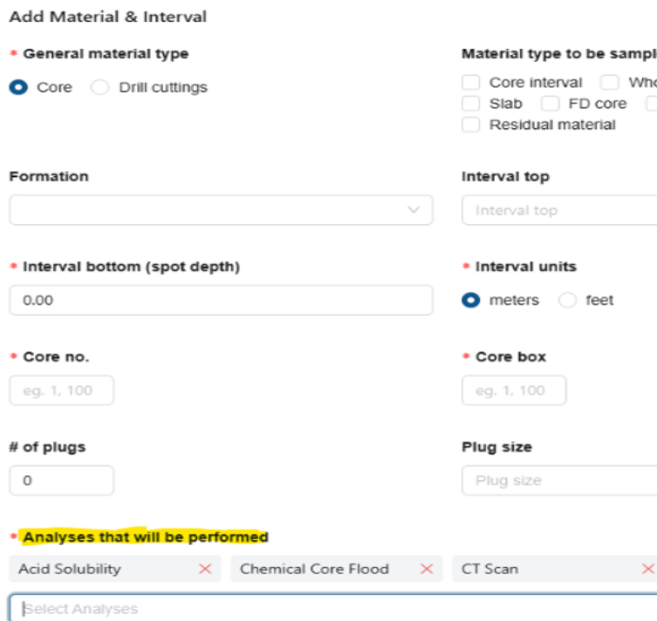
- How do I indicate on the form all the material types for sampling?
- On the Add Material & Interval screen, under “Material type to be sampled,” check the boxes for each material type to be sampled.
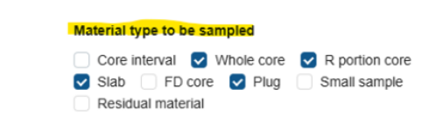
- Can I submit a sampling request for multiple wells on one form?
- Yes, you can include multiple wells on one sampling form. On the left side of the screen, select +Add UWI. Add the additional wells to your sampling form.
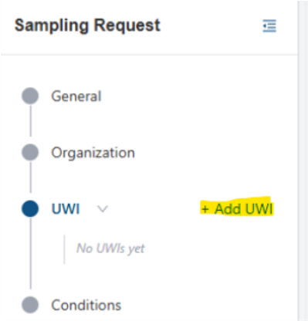
- How do I add multiple sampling depths to the form?
- You can add multiple depths in two ways:
- Create a new entry for each depth. Select +Add Material & Interval and enter the information for a new depth.
- Copy an existing entry using the copy material (green icon) in the Actions area (see below). If you copy an entry, be sure to update the depth for the new sample and adjust the core and box numbers if needed.
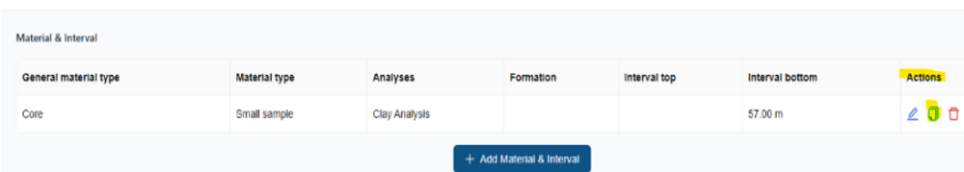
- How do I edit or correct data on the Add Material & Interval screen?
- After the record appears on the screen, select the pencil (blue icon) in the Actions area to enable editing.
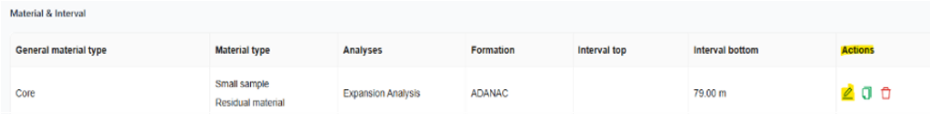
- How do I delete an entry from the Add Material & Interval screen?
- After the record appears on the screen, select the garbage can (red icon) in the Actions area.
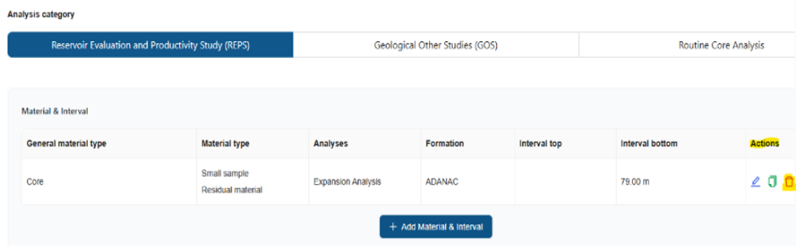
- How do I proceed to the final screen and form submission?
- Once you have completed all screens, including at least one Material & Interval screen, you will be able to proceed to finalizing and submitting the form.
- On the final screen, how do I submit the form?
- To submit the form, set all conditions to “Yes,” except “I am physically at the CRC.” You do not need to be at the CRC to submit the sampling form. If you are physically at the CRC, select “Yes” for this condition.
- How do I submit my core analysis or drill cutting test results?
- Once the sampling form is approved, you will receive an approval email from the CRC. In the approval email, select the “Click Here” link (shown as white text on a blue background) to open the approved sampling form. On the left side of the form below, under the sampling request number, select Submissions. On the upper right of the screen, select +Add Submission. Complete the required fields and include any needed notes. You can submit both core analysis and drill cutting test results on one form. When you are done, select Create Submission.
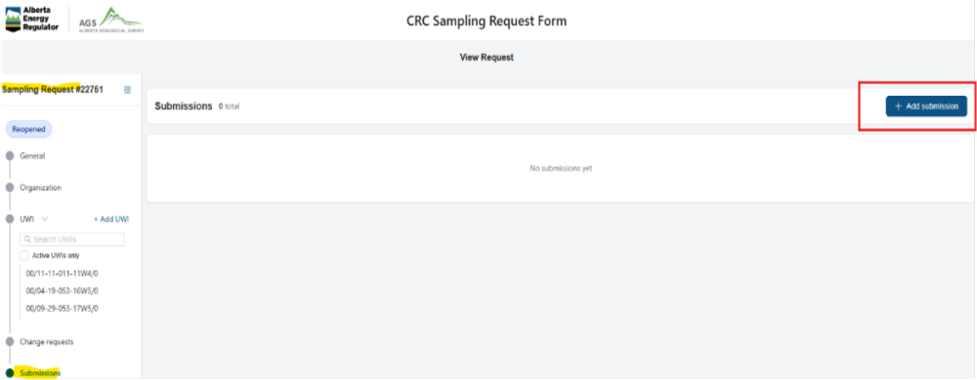

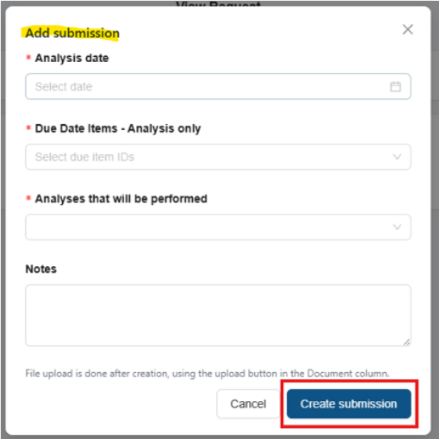
- What should I do if I lose or delete the email for submitting core analysis test results?
- Email crccomplianceadmin@aer.ca and request a new approval email. A CRC Compliance team member will resend the email with the link.
- Can I amend or update my sampling request after it has been approved?
- Yes. In the approval email you received from the CRC, select the “Click Here” link (shown as white text on a blue background) to open the approved sampling form. On the left side of the form below, under the sampling request number, select UWI and the well or wells to amend. On the next screen, select Add change request. Complete the required fields and include any required notes. When you are done, select Submit.
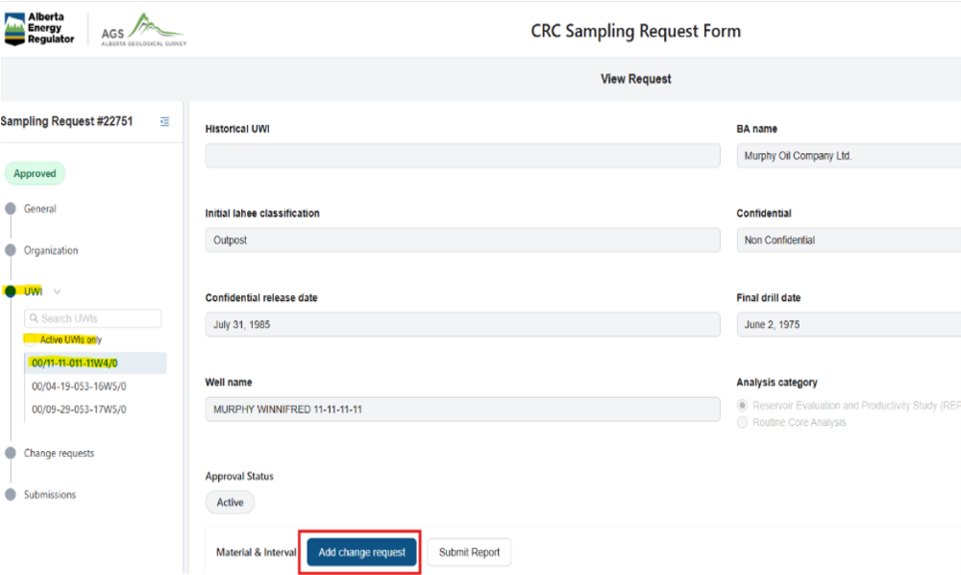

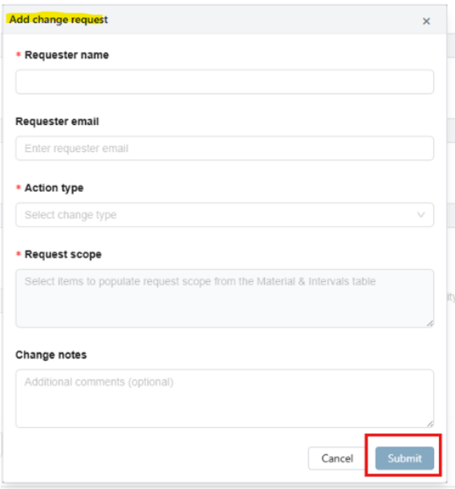
- Can I extend testing timeframe?
- Yes, depending on circumstances. You can either email crccomplianceadmin@aer.ca to request an extension or submit a change request (see Question 18). In the notes section, request an extension and explain why. Be sure to identify the well or wells for which you are requesting the extension.
- Once the sampling form has been approved, can others in my organization or staff from the lab doing the testing access the form?
- Once the form is approved, the manager, lab staff, and the person who completed it can access the form.
- Will I receive reminders about sampling request submission and test result deadlines?
- You will receive email reminders before testing results, samples, sample residuals, plugs, and thin sections are due. You will also receive notices of noncompliance when submission requirements are overdue.
- How long does it take for sampling approval?
- Approval may be granted immediately or within two business days.
- Where can I view and access core analysis test results for nonconfidential Alberta wells?
- Core analysis test result data are available in the searchable GOS and REPS database.

